# INTRODUCTION

* 1. Overview
* The air transport system generally includes airports, ATC(Air Traffic Control) system, and airlines.
* The airports represent the ground part of the system’s infrastructure handling the aircraft operated by different airlines transporting passengers and freight shipments.
* Air transport in India was started in 1911. It is a managed by air India. Indigo, air India and Goair are the major transit corporations.
* India’s is the world’s third-largest domestic and overall civil aviation sector.
  1. Purpose
* Air transport is one of the fastest modes of public transport which connects international boundaries.
* Air transport allows people from different countries to cross international boundaries and travel other countries for personal, business, medical and tourism purposes.
* India’s airways provides direct flight connections to major global hubs in North America, Europe, Asia and the middle East.
* This network of air routes enables swift and efficient travel for business, tourism and diplomatic purposes, fostering stronger global ties.

1. **Problem Definition & Design Thinking**
   1. Empathy Map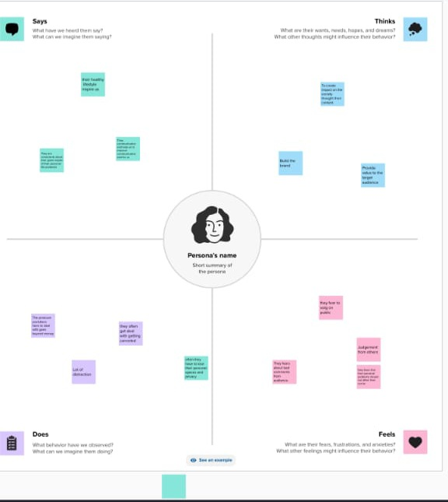
   2. Ideation & Brainstorming Map

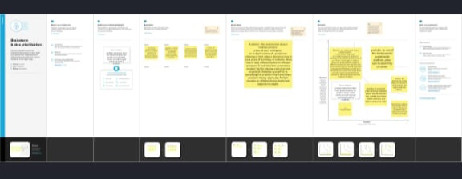

# RESULT

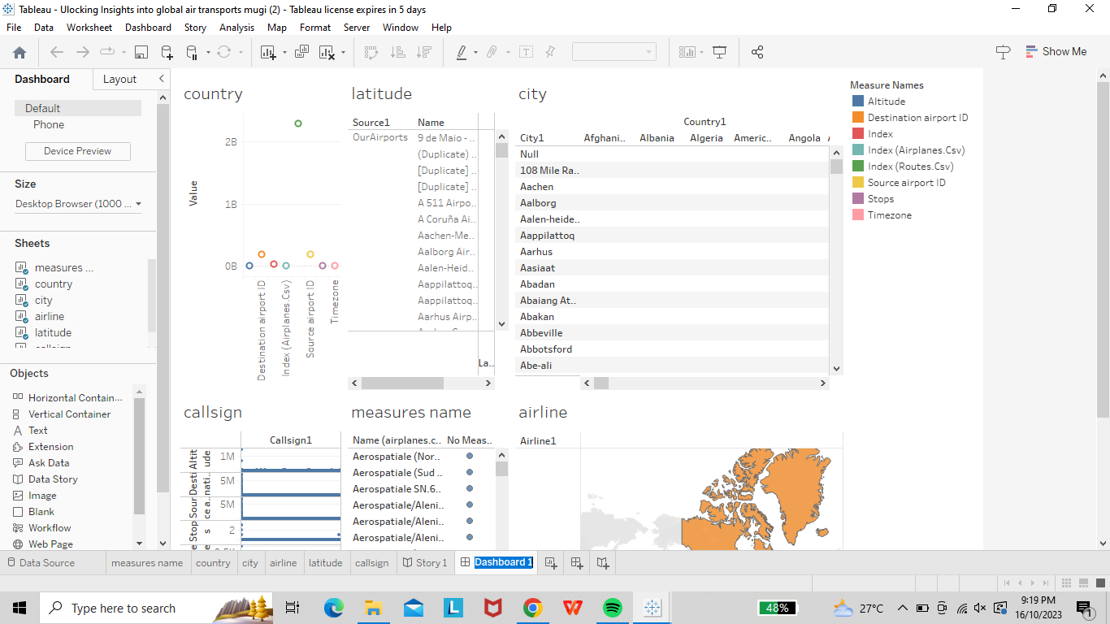

* 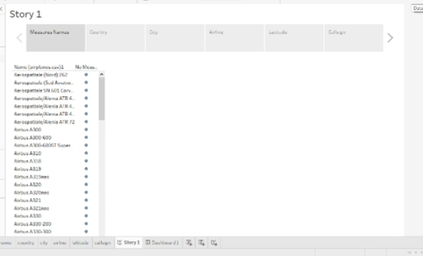

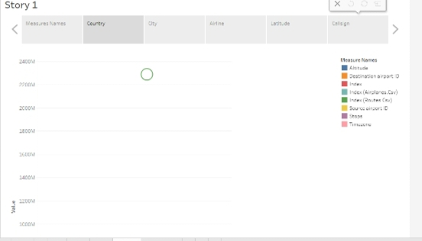

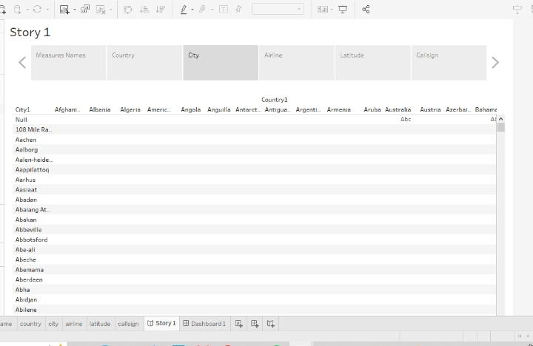

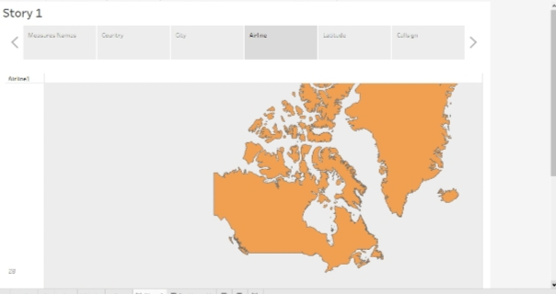

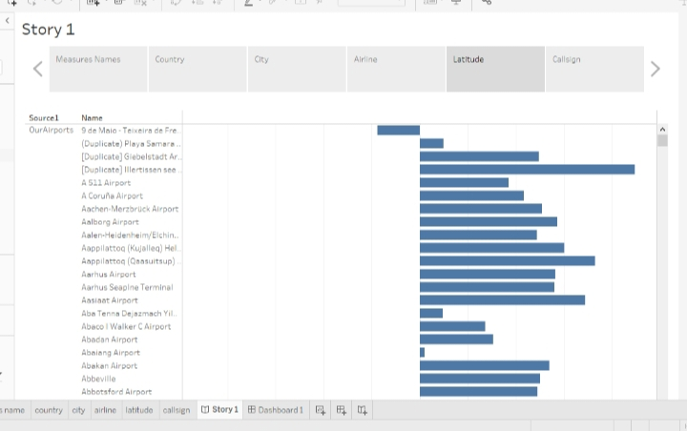

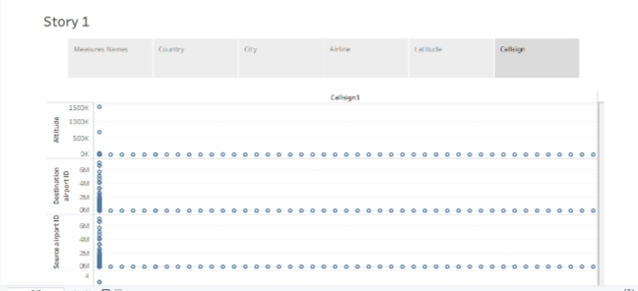

# ADVANTAGES & DISADVANTAGES

ADVANTAGES:

* It generates economic growth, provides job, increases revenue from taxes, and fosters the conversation of protected areas.
* Its ability as an economic engine to generate and support jobs, strengthen trade and connectivity between people and countries, promote tourism and connect remote communities.
* Air transports facilitates integration into the global economy and provides vital connectivity on a national, regional and international scale.

DISADVANTAGES:

* Air transport can involve higher costs then other options, and is not suitable for all goods.
* Flights are subject to delay are cancellation. You will need to pay tax at each airport you use.
* Globalization has had a significant impact on air traffic growth.

# APPLICATIONS

* As passenger volumes increase faster than new airports are terminals can be build, demand is placed on airport management for more complex and timely decision.
* Costs must be controlled, productivity must be provided and security enhanced. And all of this must be done at the same time as meeting the increased expectations of passengers for smooth and efficient servicer which ensure hassle-free travel.
* These include Wi-Fi, Bluetooth, video/biometrics, airport operational data bases, common –use systems, baggage systems and customer satisfaction monitoring systems.
* Collaborative decision making(CDM) is top of the agenda at many airports today.

# CONCLUSION

* Air India has established its position as India’s largest and most effective air carrier on all fronts.
* Enhance efficiency and sustainability of flight operations by optimizing routes and enhancing airline traffic prediction and flow.
* Low- cost carriers have tremendous success in aviation.
* An airline is a company that provides air transports service for travelling passengers and freight.

# FUTURE SCOPE

* Emerging technologies are reshaping with robotics, artificial intelligence, the internet of things, unmanned aircraft systems and the push for hybrid and electric airplanes.
* The future of aviation holds immense potential for expansion, advancement, and the generation of new employment opportunities.
* The aviation industry is a highly diverse field that offers a multitude of carrier opportunities, ranging from pilots and air traffic controllers to engineers and maintenance technicians.
* As the aviation industry continue to grow, so do the carrier opportunities in this field.

# APPENDIX

1. Source code



<https://public.tableau.com/views/UlockingInsightsintoglobalairtransportsmugi/Story1?:language=en-US&publish=yes&:display_count=n&:origin=viz_share_link>

<https://public.tableau.com/views/UlockingInsightsintoglobalairtransportsmugi/Dashboard1?:language=en-US&publish=yes&:display_count=n&:origin=viz_share_link>

|  |  |  |  |
| --- | --- | --- | --- |
| |  | | --- | |  | |  | https://mail.google.com/mail/u/0/images/cleardot.gif  https://mail.google.com/mail/u/0/images/cleardot.gif |
|  |
| |  | | --- | |  | | | |  |